MAC United FAQ-Parent Handbook
Outdoor 2023
Developing Excellent Players and Outstanding People
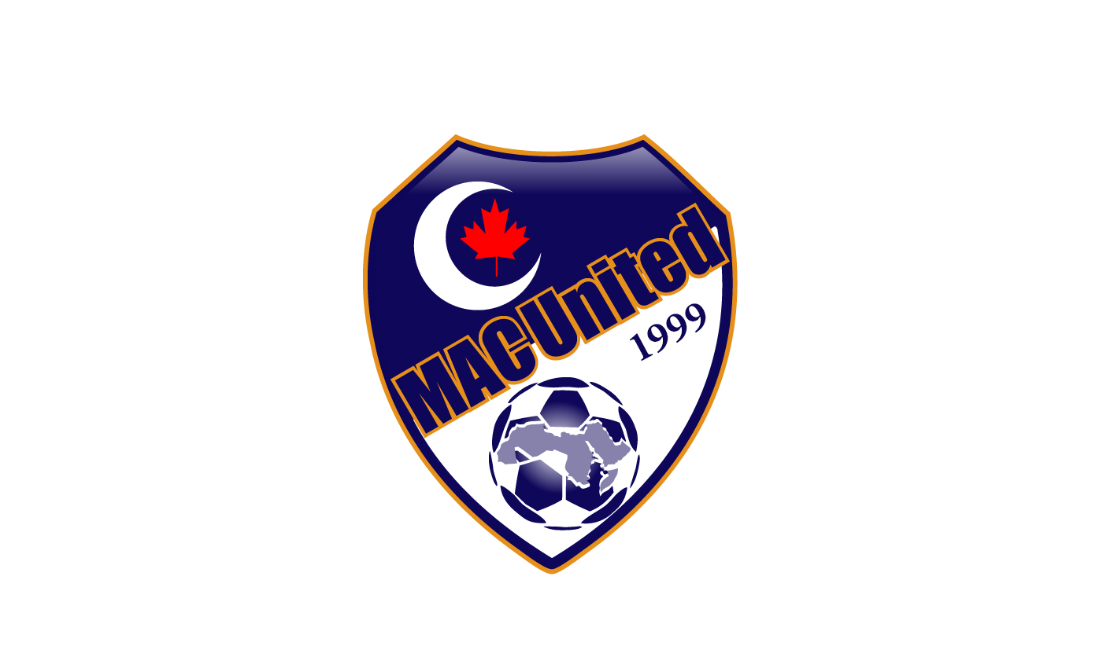

Table of Contents

Parents Roles & Responsibilities 3
Player uniform & equipment 3
Program Structure: 4
House League- U4-U6 4
U7-U9 4
U10-U13 4
U14-U19 5

Parents Roles & Responsibilities

Parents are responsible for:
- Parents are responsible for bringing players in their proper athletic attire
  - water bottle
  - light snack
  - proper athletic clothing for practice (loose clothing, sweatpants, running shoes, cleats)
- Making sure players arrive to practice, matches & games on time
- On match days parents are expected to bring the players 15-mins before the match/game
- Signing waivers and/or any necessary documents required
- Communicate openly with coaches
- Communicating with coaches whether their player(s) will be attending practices, matches & games
- Modeling good sportsmanship
- Refrain from criticizing referees
- Avoiding conflicts with parents from your team and the opposing team
- Be respectful to coaches. If you have any ideas or concerns, schedule a time before or after practice and work with the coaches for the betterment of the team.
- Let the coach do his/her job; avoid yelling instructions to players from the sidelines
- Any official complaints must be sent by email to info@mac-united.ca

Program Structure:

House League- U4-U6

This program focuses on introducing youth to soccer through interactive and team building soccer games. Our focus is to ensure that every player enjoys the game of soccer in a fun learning environment within their community with friends. It is expected that parents are on the field watching their players.

U7-U9
MAC United is partnered with the Calgary Minor Soccer Association (CMSA). U7-U9 youth participate in the CMSA matches regulated by coaches that are aimed at developing the players' soccer and teamwork skills. Players will be playing 7 matches before the summer break on June 26-Aug 25. After the summer break there is an optional 4 matches after the summer break.

 | U7 | U8 | U9
Season Dates | Spring: May 6- June 24  optional Summer:  Aug 26-Sept 23 | Spring: May 6- June 24  optional Summer:  Aug, 26-Sept 23 | Spring: May 6- June 24  optional Summer:  Aug 26-Sept 23
# of Matches | 11 total | 11 total | 11 total
Play Dates | 1 Match per week on Saturdays  Quadrant based:  Genesis Centre (NE) | 1 Match per week on Saturdays  Quadrant based:  Genesis Centre (NE) | 1 Match per week on Saturdays  Quadrant based:  Genesis Centre (NE)
Match Length | (3) 20- min matches | (3) 20-min matches | (3) 25-min matches

U10-U13
MAC United is partnered with the Calgary Minor Soccer Association (CMSA). Developmental soccer is targeted for players who love soccer and are committed to the game. Aimed at players looking for increased play, training opportunities within the club.
 | U10 | U11
Program | Developmental & Developmental plus | Developmental & Developmental plus
Season Dates | April 29-July 30 | April 29-July 30
# of Games | 11 | 14-16
Play Dates | Any day of the week | Any day of the week
Match Length | (1) 50-min match | (1) 50-min match
Post Season | July 29 & 30 | July 29 & 30

 | U12 | U13
Program | Tier 1-5 | Tier 1-5
Season Dates | Tier 1 & 2  April 29-July 30 & Aug 21-Sept 24  Tier 3 & 4  April 29-July 29 | Tier 1 & 2  April 29-July 30 & Aug 21-Sept 24  Tier 3 & 4  April 29-July 29
# of Games | 14-16 | 14-16
Play Dates | Any day of the week | Any day of the week
Match Length | (2) 35-min halves | (2) 40-min halves
Post Season | Tier 1 & 2 Sept 23/24  Tier 3 & 4 July 29 & 30 | Tier 1 & 2 Sept 23/24  Tier 3 & 4 July 29 & 30

U14-U19
MAC United is partnered with the Calgary Minor Soccer Association (CMSA). Tier I and II is for players more developed and experienced in soccer. For families committed to 3 or more soccer activities each week. Tier III and IV for more recreational players who are entering the sport for the first time. For families committed to less soccer training and activities.
 | U14 | U15 | U16 | U17 | U19
Tiers Offered | Tier 1-5 | Tier 1-5 | Tier 1-5 | Tier 1-5 | Tier 1-5
Season Dates | Tier 1 & 2  April 29-July 30 & Aug 21-Sept 24  Tier 3 & 4  April 29-July 29 | Tier 1 & 2  April 29-July 30 & Aug 21-Sept 24  Tier 3 & 4  April 29-July 29 | Tier 1 & 2  April 29-July 30 & Aug 21-Sept 24  Tier 3 & 4  April 29-July 29 | Tier 1 & 2  April 29-July 30 & Aug 21-Sept 24  Tier 3 & 4  April 29-July 29 | Tier 1 & 2  April 29-July 30 & Aug 21-Sept 24  Tier 3 & 4  April 29-July 292
# of Games | 14-16 | 14-16 | 14-16 | 14-16 | 14-16
Play Dates | Any day of the week | Any day of the week | Any day of the week | Any day of the week | Any day of the week
Match Length | (2) 45-min halves | (2) 45-min halves | (2) 45-min halves | (2) 45-min halves | (2) 45-min halves

