MAC United Coaches Handbook

Developing Excellent Players and Outstanding People
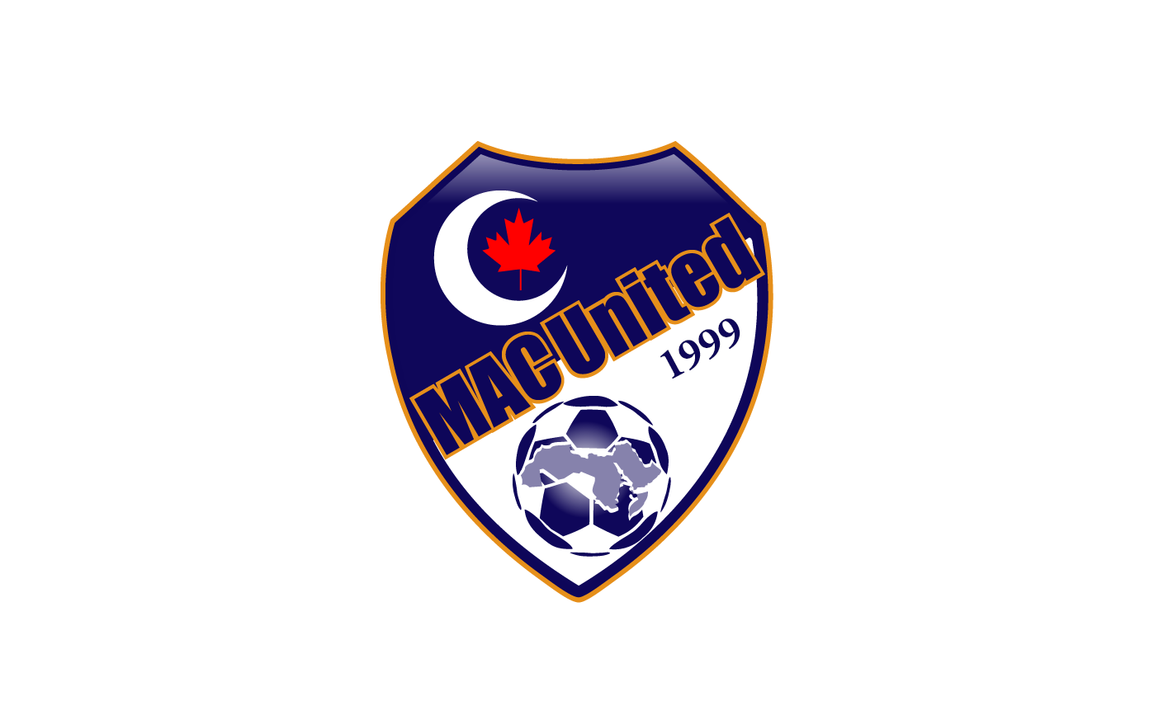

MAC United Core Values 2
Our Story 2
Our Mission 2
Our Vision 2
Our Principles 2
Soccer Coach Job Details & Tasks & Responsibilities 4
Soccer Coach Training 6
Respect in Soccer: 6
Police Clearance Check (e-PIC): 6
Basic Coaching Concepts & Drills 7
Stretches 7
Soccer Concepts 8
Basic Soccer Drills & Games 9
Resources: 13
MAC United Equipment Sign-in/out Form 14
Jersey sign-up: 15

MAC United Core Values

Our Story
MAC United Soccer Club started up in 1999 by a group of youth playing soccer for fun. With time, those youths envisioned to start a soccer club where people can enjoy playing soccer and spend good quality time with each other. Shortly after, this idea came to life and MAC United Soccer Club came to existence and became the first and so far the only Muslim Soccer Club in Calgary (one of the projects of Muslim Association of Canada). MAC United provides a healthy environment for the kids to stay active, to make new friends and to enjoy playing one of the most popular sports in Canada, Soccer.

Our Mission
Our mission is to establish a strong presence in the Calgary soccer community where youth and adults can enjoy playing both developmental and recreational soccer. MAC United is at the forefront in articulating vision, developing leadership, mobilizing grassroots, and encouraging the spirit of volunteering and giving back to the community. MAC United welcomes the opportunities to engage new hearts and minds and to form new partnerships and alliances to help make Calgary a better place for all Canadians.

Our Vision
Through its individual-empowerment and community development framework, MAC United is committed to its vision:
- Continue to be governed and operated by volunteers.
- Provide a platform for athletes to excel in the sport of Soccer and to learn about good sportsmanship.
- Provide an opportunity for parents to become coaches where they learn about soccer and teach it to the kids.
- Engage the community to help support our club through establishing a great partnership with sponsors.
- Strive to buy our own soccer facility where kids can have more access to soccer.

Our Principles
- We provide and promote fairness and equality for all participants.
- We respect the diversity within our soccer community.
- We create a fun learning environment.
- We instill positive life skills through our programs.
- Our programs provide the opportunity for soccer education and personal growth.
- Respect for teammates, coaches, officials, volunteers, parents.
- We provide a safe environment in which to enjoy soccer.
- Development of self – esteem.

Soccer Coach Job Details & Tasks & Responsibilities
Job Details
All coaches must complete the following:
- Respect in Soccer Course to become certified- CMSA website
- CMSA Coaches Card & CMSA number
- Completing and signing CMSA waiver forms
- Police Clearance
- First Aid training
- Creating an ADP Account and filling in your hours every week

Coach Requirements:
- A background in athletics and fitness
- Needs to attend meetings, technical training sessions
- Coaches are NOT allowed to recruit players from the MAC United Soccer Club to other clubs they are coaching
- Respectful and professional attitude towards MAC United Staff, parents, players and other coaches
- Demonstrating a positive and professional attitude and wearing proper attire to soccer sessions (athletic clothing, sneakers/cleats)
- Organized training sessions
- Players are stretching/warming-up for 10-15mins each practice session
- Organizing soccer drills and implementing technical skills during each practice session
- Keen interest in learning and growing
- Optimistic attitude, positive mindset & reliability
- Have an openness for constructive feedback
- Flexibility
- Creating an Islamic environment for the kids such as:
- Promoting teachings of the Prophet (PBUH): fairness, sportsmanship, brotherhood & sisterhood & respect for one another
- Constant reminders or lessons circulating around islamic themes
- Using encouraging islamic language such as “MashAllah, Alhamdulilah,”

Tasks and Responsibilities:
- Being able to facilitate and coach children in a supportive team environment
- Being able to integrate CMSA league structure (matches & game structure) into practices
- Dealing with & resolving conflicts
- If coache(s) are unable to resolve a conflict, coaches are responsible & required to report the incident to MAC administration
- Communicate with parents and checking up on players missing payments & practices
- Bringing in equipment to practice and taking proper care of soccer equipment
- Constant communicating with the MAC United Soccer Staff
- Taking attendance every practice & game to ensure players are coming
- Making sure U11+ get their CMSA Card & signing their waivers
- Asking parents to confirm their attendance to practices & games
- Hosting practice sessions with 4-15 players between the ages of 6-15 years old for 60min
- Communicating effectively to parents and children fostering positive relationships
- Being able to organize training sessions/classes & equipment
- Participating & attending staff meetings, on-going training & in-house certification
- Demonstrating a positive and professional attitude
- Taking pictures for their team during games & practices
- Able to navigate through TeamSnap scheduling practices and games & CMSA software (Demosphere)
- Making up missed or canceled practice sessions
- Communicating with other coaches if you are unable to attend practices or games
- Checking the weather & canceling practices in case of: rainstorms, extreme weather, smoke, snowfall

Soccer Coach Training

Respect in Soccer:
Coaches are required to complete a Respect in Soccer Course to create a positive soccer experience for players. The cost to certify in the program is $30.00. Please visit the CMSA website or click the link below to begin the course.
Respect in Sport | Calgary Minor Soccer Association

Police Clearance Check (e-PIC):
Coaches are required to complete a police clearance. A police clearance is valid for 3 years from the date it was issued. Please follow the read the following documents below or visit CMSA on how to e-PIC
Police Clearance (ePIC) | Calgary Minor Soccer Association
https://calgaryminorsoccer.demosphere-secure.com/_files/coach-manager/police-clearance/Security%20Clearance%20Program%20%20CMSA%202022.pdf
https://policeinformationcheck.calgarypolice.ca/

Basic Coaching Concepts & Drills

Stretches
It is important that players stretch for 10-15 minutes before the practice session to reduce tightness and pain in the muscles and to improve performance overall.

List of Basic Stretches:

- Laps
- Line cone drills
- Set up 3-5 cones at equal distance from each other
- Sprint to and touch Cone #2 and sprint back to Cone #1
- Sprint to and touch Cone #3 and sprint back to Cone #1
- Repeat for the remaining cone, when the players reach the last cone they will sprint to and touch Cone #1, sprint to the last cone and back to Cone #1
- Butt-Kicks: Players will stand straight and jog while bringing their feet to their rear end
- High-Knees: Players will job and bring their knees as high as they can, trying to bring it
to their chest
- Backward Jogging
- Arm circles: Rotate your arms at the shoulder in a full circle forward and backward for 10 seconds.
- Ankle rotations: Have players stand with their toes pointed to the field and rotate their ankles in circles. Repeat with the opposite foot.
- Quad stretch: Hold outside foot with your outside hand and lift the foot toward your rear end keeping your thighs and knees together.
- Push-ups
- Burpees
- Lunges
- Jumping Jacks
- Circuit Runs: Short runs consisting of dynamic running; jogging a certain distance, then sprinting quickly, then slowing down again to a jog with no breaks.

Soccer Concepts

Dribbling | Encourage players to dribble, stop and turn the ball as well as have the players moving in different directions. Coaches can line cones in a straight or zig-zag fashion. Have players weave/dribble through the cones to help players practice this skill.
Passing | Encourage players to stand in a circle and have them pass and call out to the team member they are passing to. Also encourage players to split into partners and practice doing short quick passes with one another.
Shooting | Coaches should encourage and teach players to shoot from various distances and angles. Teach players that the objective of the game/exercise is to score more goals than the other team in a fixed period of time.
Defending | Encourage players to move forward when the ball is taken away from them and to move forward when attacking.
Transition | Offense & defense. Regaining possession of the ball and to counter-attack a goal.

Basic Soccer Drills & Games
U4-U10

Game/Drill: | Instructions:
Island Hopping | Objective: To have the players keep their heads up while dribbling  Set up: Use 3 cones to set up a square of 4 different islands. Make sure the islands are spaced out evenly  Game: Choose one player to be a pirate and have the pirate stand in the center. Have the remaining players stand at any island with a ball. The players must dribble the ball to any island. Once they have reached the island safely they can only stay for 15 seconds. Once the players leave the island they can not return, they must move to the next island. The pirate must steal or kick the players balls away. Once the ball is stolen from a player they also become a pirate. Last player standing wins.
Tag | Objective: To have the players keep their heads up while dribbling  Set up: Set up a square using cones to create the boundary.  Game: Have one player be “it”, the remaining players must dribble inside the square. If they get tagged they must leave the square and do 6 toe touches and enter the game again.
Space wars | Objective: To have the players keep their heads up while dribbling  Set up: Set up a square using cones to create the boundary.  Game: Have the players run around in the square and the coaches must hit the players with a ball at the shins. Once a player is hit, have them sit inside the square. Last player standing wins
Minions | Objective: To have the players keep their heads up while dribbling close and shooting.  Set up: Set up a square using cones to create the boundary.  Game: Choose a minion, the minion will have a ball and the remaining players will run around in the square. The minion will dribble around the space and must hit a player with the ball. Once a player gets hit, they get a ball and become a minion. Last player standing wins.
Freeze Tag | Objective: To have the players keep their heads up while dribbling.  Set up: Set up a square using cones to create the boundary.  Game: Have one player be “it”, the remaining players must dribble inside the square. If they get tagged they must leave the square and have to dribble the ball in between their legs 5 times to unfreeze themselves.
Sharks & Minnows | Objective: To have the players keep their heads up while dribbling.  Set up: Have the players divide into partners and have them stand parallel from each other. Choose one or two sharks to be in the middle.  Game: The ‘minnows’ must dribble the ball to their partner without getting their ball stolen by the shark. If their ball gets stolen they become the shark and the “first shark” becomes a minnow (switch places)
Dancing ball | Set up: Create a circle using cones, space the cones evenly.  Game: Have the players start at a cone and dribble next to the circle of cones. Yell stop and at each cone they practice a skill.  Toe taps, go around the cone with the ball, tap ball with outside foot, tap ball with inside foot, dribble the ball between their feet
Red light, Green light | Objective: Have the players practice dribbling & speed.  Game: Have the players stand in a line or anywhere around the field. Coaches will yell green light (dribble fast), yellow light (dribble slow), red light (stop with one foot on the ball).
Defender | Objective: Passing, defending & dribbling.  Set up: Set up a mini-game using cones and use one bow net.  Game: Have 2 or 3 players passing the ball to each other and one defender trying to defend the goal.
The jungle | Objective: To have the players keep their heads up while dribbling.  Set up: Scatter cones around the field randomly  Game: Scatter the cones on the field (trees) they have to dribble around the cones, if they touch the cone they have to do six toe taps on the ball
Striker | Set up: Have the players stand in a circle spaced out from the other players.  Game: Choose one player to be the striker. The players around the circle must pass the ball really fast before the striker steals the ball. Once the striker steals the ball, the player who did not receive the ball is the new striker.
Duck- tails | Objective: To have the players keep their heads up while dribbling  Set up: Set up a square using cones to create the boundary.  Game: Players will have a pinnie at the back of their shorts/pockets and have to dribble a ball and must take a pinni from their members while protecting their own. The player with the most pinni’s wins.
Knock-out | Objective: To have the players keep their heads up while dribbling  Set up: Set up a square using cones to create the boundary.  Game: Have the players dribble their own ball and must kick another player's ball outside the square if your ball gets knocked out you have to dribble the ball side to side to get back in the game
Relay Races | Objective: To improve players game sense and speed with drills by competing with other teammates in the same drill  Set up: Divide a certain drill you want to work on with your players into an equal amount of the players you have.  Game: Have the players compete at the same time over who can complete the drill the fastest and with the best accuracy. Players who make a mistake in the drill must restart.
Timed Drills | Objective: To ensure players are playing with excellent accuracy and speed.  Set up: Any drill which involves kicking/passing/ scoring within a group effort or individual effort.  Game: Have the players be aware of a target time they must complete the drill within using accuracy and speed. Adjust the time given based on the player's level and success in completing the drill.
Monkey In the Middle | Objective: To improve team communication and passing accuracy.  Set up: Set up cones to a big circle shape.  Game: Have the team spread out in the circle, and instruct a player to call the name of another player and pass the ball to them and continue the cycle.

Resources:
Dynamic Soccer Stretches | PRO TIPS by DICK'S Sporting Goods (dickssportinggoods.com)
https://www.soccerdrive.com/learn-how-to-coach-soccer
10 Soccer Ball Drills and Games (schoolspecialty.com)
10 Best Soccer Drills for Kids | MOJO Sports
How to coach youth soccer (footy4kids.co.uk)

MAC United Equipment Sign-in/out Form

MAC United Coaches are required to take care & manage soccer equipment. Any damaged/missing equipment must be reported via email to MAC administration. Coaches must sign a form listing all the equipment they have at the beginning and end of the season and email the form back to MAC administration.

First Name:
Last Name:
Season: (indoor-year (and/or) outdoor-year)
Team coaching:

Soccer Equipment: | Quantity:
Soccer bag:
Soccer balls:
Soccer nets:
Cones:
Pinnies

I ______________________________________ agree to take care/manage soccer equipment and notify MAC administration of any damaged or missing equipment. I am also responsible for any damaged or missing equipment given out by the MAC United Soccer Club.

____________________________ __________________________
Name Date

____________________________
Signature

Jersey sign-up:

Players Name (First & Last Name) | Jersey Number

